com_inscricaoexames how-to

Unzip the file
Download the file and unzip it. Inside there are 2 files, one is the component, and the other is a plugin. The plugin is only used when a joomla used is deleted, at this point the component database is checked to see if that user is registered in the component and if so, it deletes it from the component DB. If you don't want this to happen, don't install the plugin, or leave it unpublished.

Install the component and the plugin (back-office)
In the back-office install the component going to: Extensions > Install/Uninstall > Select the file to upload (com_...) and press “Upload File & Install”.
Do the same for the plugin. (Don't forget to publish it)

Set up the menu items (back-office)
This component has 5 menu items:
- Menu de administração: A front end menu for the administrator insert and edit data, as well as see the exams lists, specific student exam list, print the lists, reset the lists, and set up some options. This menu item should be in the Admin menu;
- Registar aluno: This is used for a registered joomla user to register himself in the component. When users are inserted in the component by the admin, they have a special code, which is used for the student to register himself in the component, connecting his joomla user to the component user. This menu item should be in the registered users menu;
- Fazer inscrição v1 (AJAX): This is used by the student to enroll himself in an exam.This menu item should be in the students menu (The students group must be below the registered group);
- Fazer inscrição v2 (Javascript): The same as the previous, but programmed in a different way. You only need to use one of these 2. If the previous doesn't work for you, use this one;
- Ver inscrição: This is used for the student see which exams he enrolled himself in. This menu item should be in the students menu (The students group must be below the registered group).
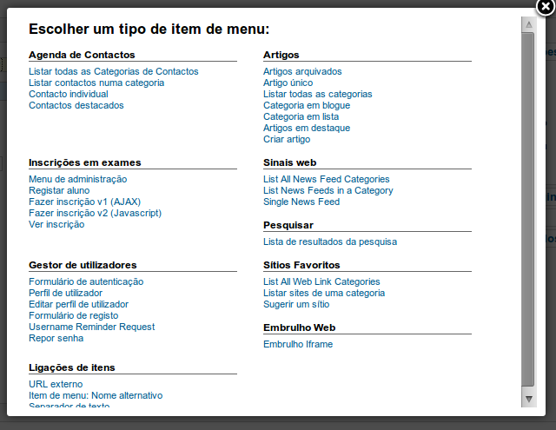

Set up options (back-office)
There are 4 options you can set up:
- Students group: The joomla group where the students will be added automatically when they register in the component. This group should have access to the menu with the menu items to use this component;
- Necessary to autorize the enrollement: Used if you need to aprouve the students exams list. For example if the students have to pay for the exames, then you only acept the enrollment if/when the payment is done. Only after the student exam list has been accepted, will it appear in the final exams listing;
- Maximum exams per student: The student will not be allowed to enroll in more exams than this. If 0, this will be disabled;
- Maximum exams per student, per subject: In each subject, the student will not be allowed to enroll in more exams than this. If 0, this will be disabled.

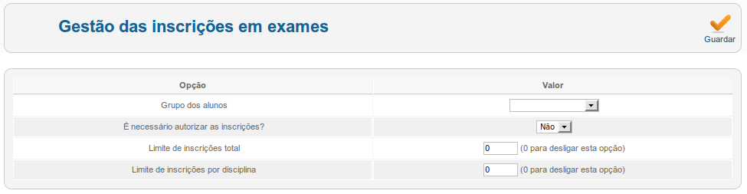

Insert data (front-end, admin)
This is the front-end admin menu:
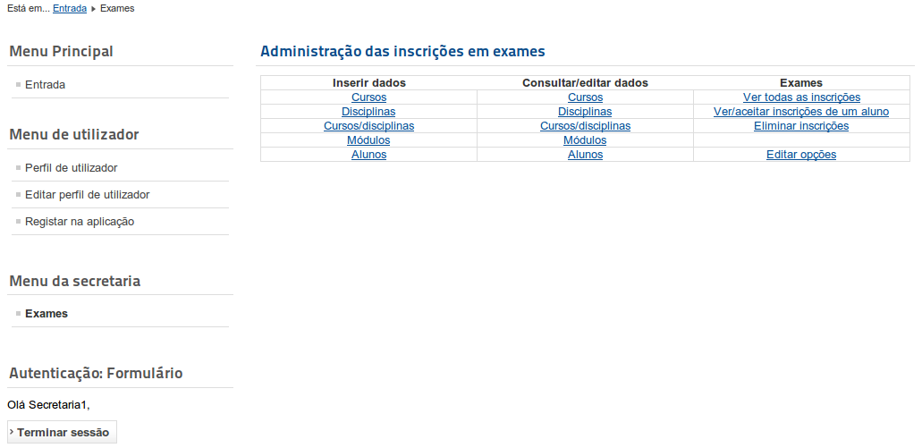
Before you start using the component you have to insert data about the courses/subjects the students cam enroll for an exam. That is done in the menu above, in the following order:
- Insert the courses;
- Insert the subjects;
- Connect the courses with the subjects in each course;
- Insert the themes in each subject;
- And finally insert the students in each course.

For steps 1 and 2, you have a form like the one below, and a small instruction on what to do. For instance, in this case, for each course you put in a line the full name of the course and the small name of the course, separated by a ';'. In the case of the subjects, you only have to insert a subject once, even if they are used in several courses.
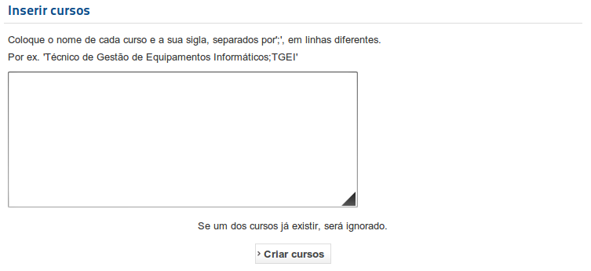
In step 3 you connect a course with the subjects. Obviously it only makes sense to o this if you already have courses and subjects inserted. Here, first you choose the course, and then you select its subjects, from the available subjects. This form is the same for editing this connections.
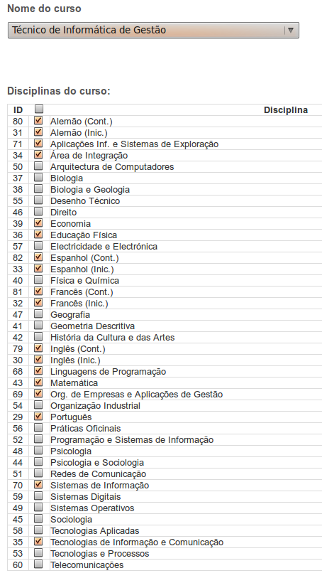
Steps 4 and 5 are quite similar. In the case of inserting the students, first you choose the course in which the students are and then you write down their ID and their name, separated by a ';', like:
“123456789;António Manuel Meirim”.
Remember: the students ID must be unique for every student!

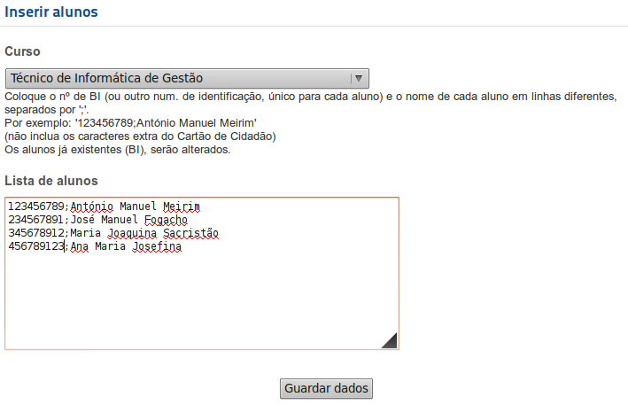
Data for the following courses (PT) is already inserted, if you don't need it, you can just delete it (or leave it, since there will be no students enrolled it those courses):
- Técnico de Electrónica e Telecomunicações
- Técnico de Gestão e Programação de Sistemas Informáticos
- Técnico de Informática de Gestão
- Técnico de Manutenção Industrial
Anyway, the subjects on those courses, and the respective themes, are already in the DB, so you can use them in the courses you will insert.

Edit data (front-end, admin)
In the menu shown below you can edit all the data you inserted before. It's pretty straight forward to use so I will not talk about it unless someone asks me for help on this.

See and print all exams list (front-end, admin)
With this item, you can see a list of all the enrollments in exams. However if it is necessary to accept a students enrollment, he's exams will only show up in this list if they are already accepted.
In this option you can also print this list. The list is ordered by subject/theme/student course/student name.
Please note that the way things are printed depends a lot on the template you are using in you Joomla platform. Don't blame me if it comes out ugly.

See, print and accept a specific student exam list (front-end, admin)
With this item, you will be able to choose a student from which you can see the list of exams he has enrolled into.
You can also choose to accept he's enrollment, and print it.
Typically, if a student has to pay for exams, he would enroll in the Internet, then go to the school and pay. In the school, after the student pays, the enrollment is accepted, printed, stamped and given to the student as proof that he payed and is authorized to make the exam.
Please note that the way things are printed depends a lot on the template you are using in you Joomla platform. Don't blame me if it comes out ugly.

Reset enrollments
After everything is done you will want to delete all enrollments, without deleting the students or the courses or any other data, so that everything can be easily used again.

Enroll in exams (front-end, students)
The students, after being registered in the joomla platform and in the component, will have access to the form to enroll in exams. In this form, they will choose the subject and the theme on which they want to enroll. They are only allowed to enroll in a subject/theme in their course, and if there are limits set for the number of exams, they will have to respect those. If it's necessary to accept students enrollments, they will only have access to this for until the school accepts it.
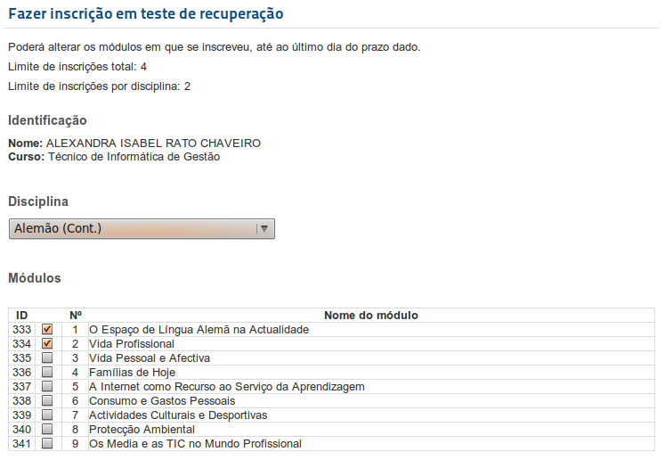

See and print exams list (front-end, students)
The students will also have access to a list with all the exams they are enrolled into. This list is ordered by Subject/theme.
Please note that the way things are printed depends a lot on the template you are using in you Joomla platform. Don't blame me if it comes out ugly.
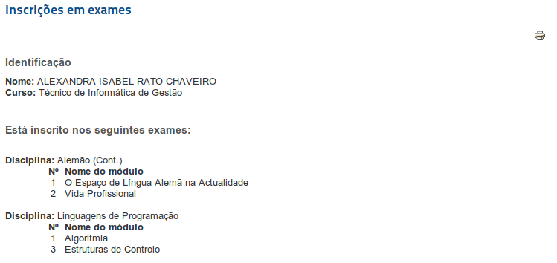

Hope its useful for someone else,
cheers,

Herberto Graça.
August, 2011

